Implementation of buffer window in fusion
1)These are the imports and global variables
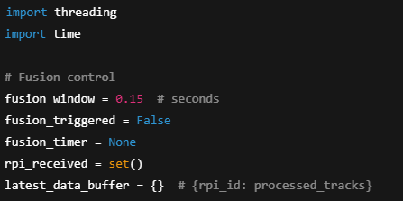
2) Implemented overwriting technic in the latest_data_buffer based on rpi_idX

3)buffer window close based on buffer window technic
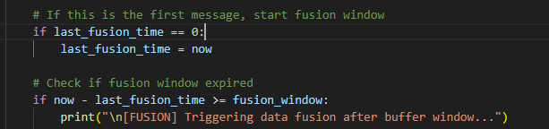
4)Fusion begins after fusion window is closed
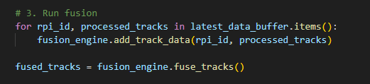

5)Fusion window will reset after each fusion cycle
